- The risk of inflation expectations de-anchoring – driven by the surge in energy prices from the Middle East conflict – will likely prompt the Bank of England to maintain current interest rates well into next year.
- The minutes from today's Monetary Policy Committee meeting emphasised a desire for flexibility amid heightened uncertainty around growth and inflation. While a hike is possible, we think the fragile economic backdrop and already restrictive policy suggest a prolonged hold is more probable than a pre-emptive hike.
The minutes of today's MPC meeting showed the conflict in the Middle East has become the key issue for all committee members, who agreed it was too soon to draw firm conclusions about the appropriate policy response – a similar message to that delivered by the Federal Reserve on Wednesday.
The individual comments by MPC members stuck to this theme, setting out a range of potential scenarios, but mostly avoiding committing to any of them. That said, the more hawkish members of the committee, particularly Huw Pill and Megan Greene, did suggest the fallout from the Middle East conflict has added to their pre-existing concerns about inflation persistence. This likely explains the relatively hawkish initial response from financial markets, as the yield on the two-year gilt spiked 30bps.
Before the outbreak of war, most of the committee had a bias to loosen further due to the weak outlook for the economy and the fragile labour market. Neither of these concerns have dissipated. If the conflict proves short-lived and oil and gas prices drop back rapidly, the dovish majority could return to their original position.
Our baseline is that global oil and natural gas prices will stay higher for longer. Our updated forecast, which we plan to publish tomorrow, assumes that the Brent crude oil price averages $113 a barrel in Q2, while higher wholesale gas prices cause a 19% increase in the Ofgem energy price cap in July. Under these assumptions, we expect UK CPI to rise to just above 4% y/y in H2.
Chart 1: We now expect the MPC to hold Bank Rate at 3.75% until well into next year
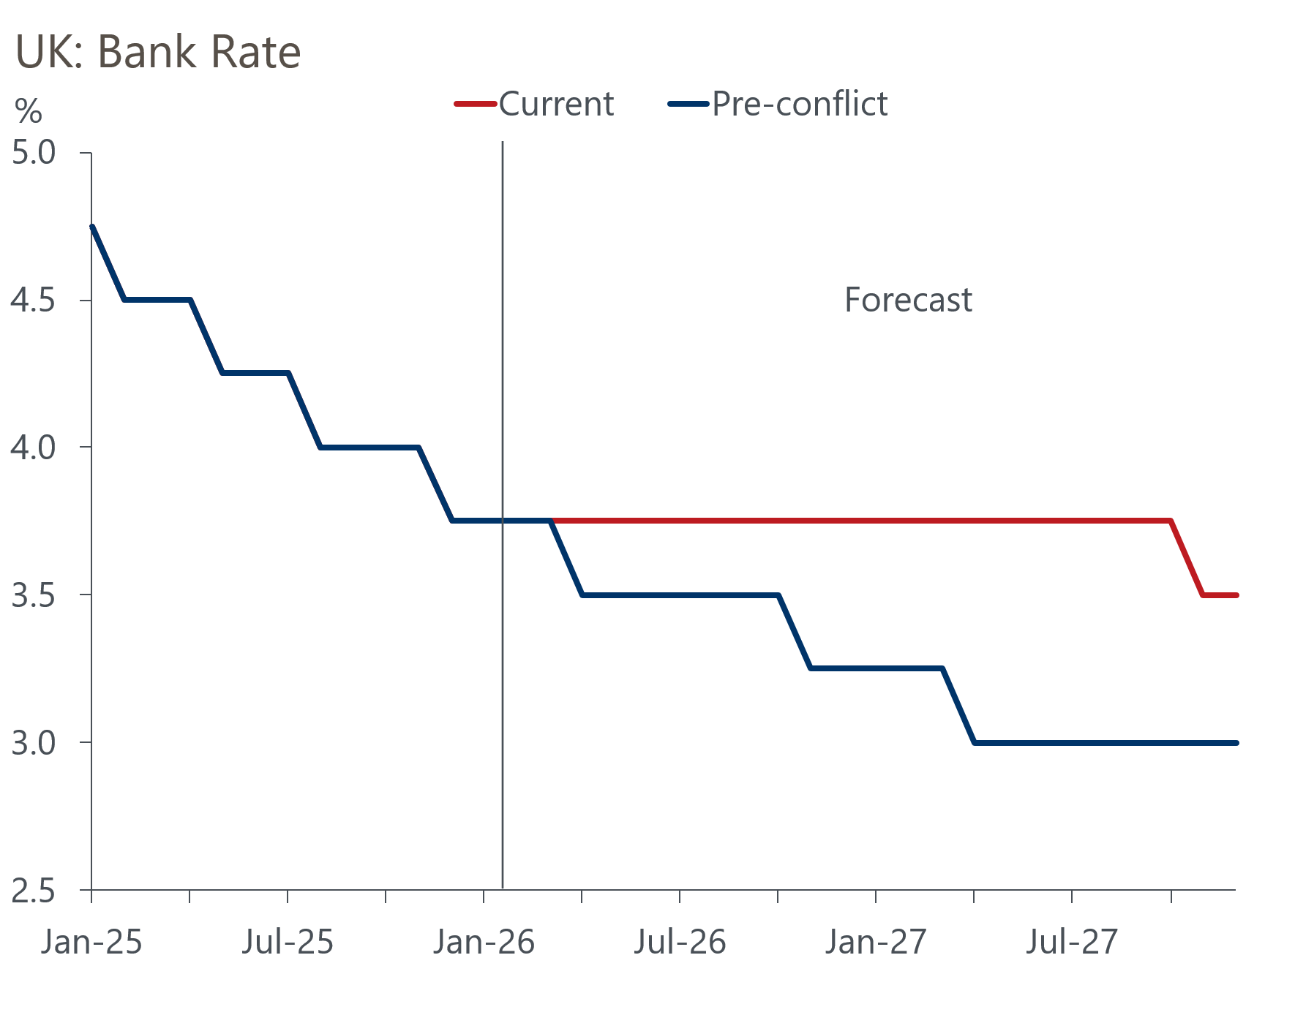
Sources: Oxford Economics, Haver Analytics

Given the experience of 2022-2023 and the risk that a period of high inflation could cause inflation expectations to become de-anchored, we now expect the committee to keep Bank Rate on hold at 3.75% for the rest of this year and well into 2027 (Chart 1).
The minutes made clear that the next move could either be a hike or cut. While we agree that a rate hike this year is possible depending on the duration of the conflict in the Middle East, it's not our central forecast. The argument in favour of a hike is that it would be a pre-emptive move against the risk of inflation expectations becoming de-anchored. While we do expect some committee members to back this view, we doubt it would generate majority support unless there was clear evidence that expectations were following this path.
Governor Andrew Bailey remarked that "the starting point for this shock is a real economy with limited pricing power". This is in marked contrast to the 2022-2023 episode. If our baseline forecast plays out, pricing power will likely weaken further because activity is likely to be softer – we forecast GDP growth of just 0.4% this year – and unemployment is set to rise further.
The other contrast with 2022-2023 is the starting point for interest rates. The committee feels that the current policy rate is "somewhat restrictive", whereas the previous energy shock took place against a backdrop of very expansionary monetary policy, as well as generous fiscal support to cushion the impact of higher energy bills on households and firms. So the need to hike rates looks less pressing from that perspective too.
On balance, therefore, we think the most likely outcome is that the MPC settles into a long period of unchanged rates. If our oil and gas price assumptions are in the right ballpark, given the concerns about inflation expectations we think the committee will be reluctant to loosen policy again until three factors align: headline inflation has dropped back to the 2% target; there are signs that core inflation is under control; and the MPC is content that pay growth is close to a target-consistent pace. Under our baseline forecast, these conditions would only be satisfied in H2 2027.

